Video Number: | V23 | Video Title: | Big 3's Happiness Report.

- Choice of visuals, visualisation techniques and appropriate use of human visual perception principles

At timestamp [0:38] shown in Figure 1, the label for the global mean values could be placed directly above the line, allowing for easy identification through the Gestalt principles of proximity and similarity. This positioning would help users quickly locate and understand the global mean.
Since the report emphasizes the United States, China, and India (the "Big 3"), the chart could either focus solely on these three countries or use the Gestalt principle of enclosure by placing boxes around them. This would make the Big 3 stand out visually, leveraging the principle of salience, where attention is naturally drawn to the boxed-in elements.

At timestamp [1:07] shown in Figure 2, although the choropleth map is visually appealing if the aim is to illustrate changes in happiness scores for the three focus countries, a multi-line chart with distinct colors would suffice.
Instead of a continuous diverging color palette, a discrete diverging color scheme could be used by categorizing happiness scores into ordinal classes, such as:
- Happy = >8
- Neutral = 4-6
- Angry = <4
This approach leverages the principle of capacity limitation, as reducing the color count makes it easier to read and interpret the values. Additionally, the Gestalt principle of similarity is applied by grouping similar happiness levels with related colors, creating visible distinctions between categories and improving readability.

At the timestamp of [2:07] shown in Figure 3, colors and textures are used to distinguish countries with consideration for color-blind users. However, this approach may be redundant as the graph already uses labels (country names) and the Gestalt principle of proximity, making it clear which line corresponds to each country. The additional textures, therefore, are unnecessary.
According to principles of graphical integrity, the number of information-carrying variables (e.g., color and texture) should align with the dimensions of the data. Adding textures without a clear functional purpose can detract from visual clarity.
A suggested improvement for this graph would be to use a consistent line style for the “Big 3” countries while applying a different texture or style only to the global mean line. This adjustment would preserve a high data-ink ratio, emphasizing critical data distinctions without extraneous elements.

At the timestamp of [3:14], shown in Figure 4, the color palette used for different regions lacks sufficient contrast, making it challenging to distinguish between regions. For example, Europe and Asia share similar colors, leading to potential confusion. Similarly, the Middle East (ME) and Africa are assigned similar colors, further complicating readability, especially when data points overlap. To improve differentiation, high-contrast colors such as blue or red (not yet utilized) could be introduced to make each region more visually distinct (principle of discriminability).
Additionally, the transition from Figure 4 to Figure 5 introduces a new set of colors, which could disrupt visual consistency. To maintain coherence and enhance comprehension, the Gestalt principle of similarity suggests using distinct shapes for different regions or countries, which would also benefit color-blind users. For further emphasis on the "Big 3" countries, assigning them the same shape but with varying levels of saliency compared to other countries could leverage the principle of salience, drawing attention to the Big 3 as the focus of the visualization.
Finally, for improved readability of the text within tooltips shown in Figure 4, using a brighter color such as white on the dark purple background would enhance legibility, ensuring that information is clear and easy to read (principle of discriminability).

- Overall Comments

The strongest feature of the video presentation is its effective storytelling, which makes the visualization easy to digest. The video starts by establishing the focus of the presentation on the "Big 3" countries, guiding viewers through an analysis of the yearly rate of change in happiness scores. The narrative highlights specific factors, such as the COVID-19 pandemic, as a potential cause for score decreases, linking it to the loss of jobs and loved ones, which adds relevance and context to the data. The video then focus on analysing factors that could affect the happiness score through their correlation analysis of social support and GDP per capita by using the scatter plots.

The weakest feature is the scope of the presentation is limited to focus on Big 3 countries (US in North America region, China and India that are in Asia) which is quite small and less significant. Expanding the scope to include additional countries from diverse regions or focusing on key countries within specific regions would make the analysis more meaningful and relatable. This broader perspective could enrich the data insights and better demonstrate global patterns in happiness scores.

Figures

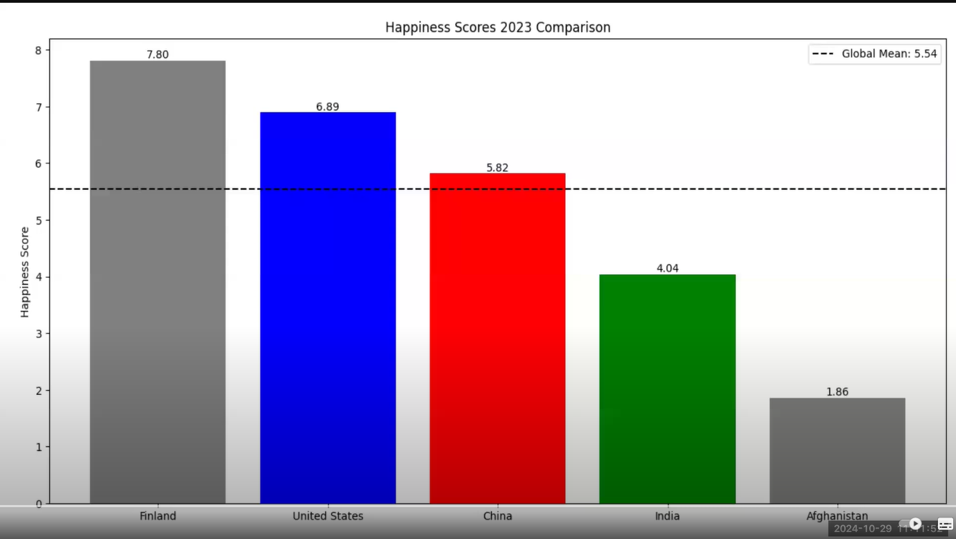
Figure 1. timestamp [0:38]
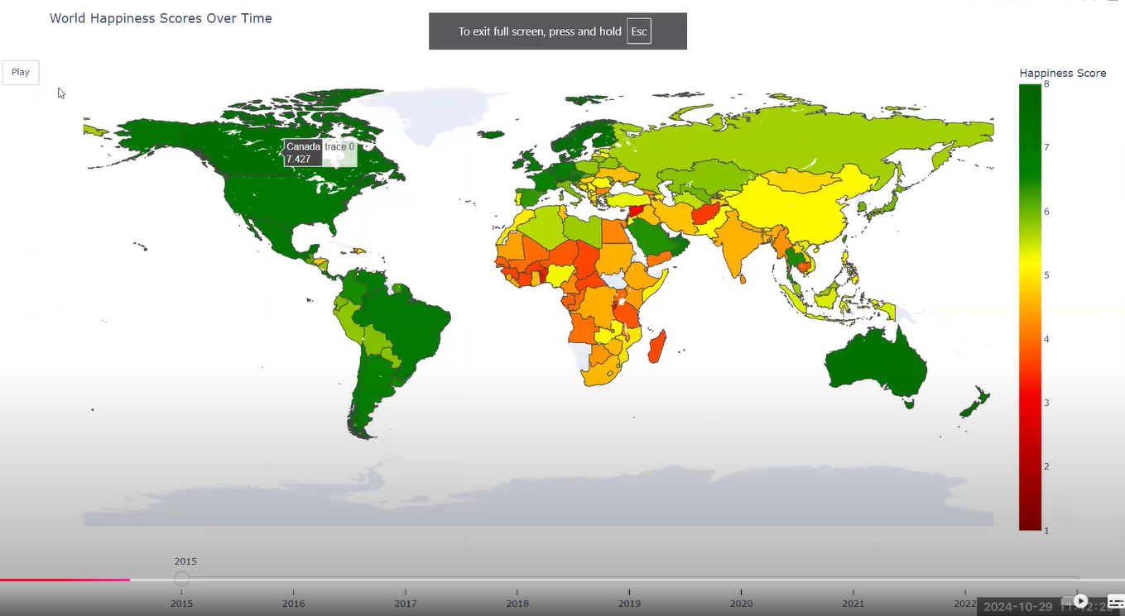
Figure 2. timestamp [1:07]

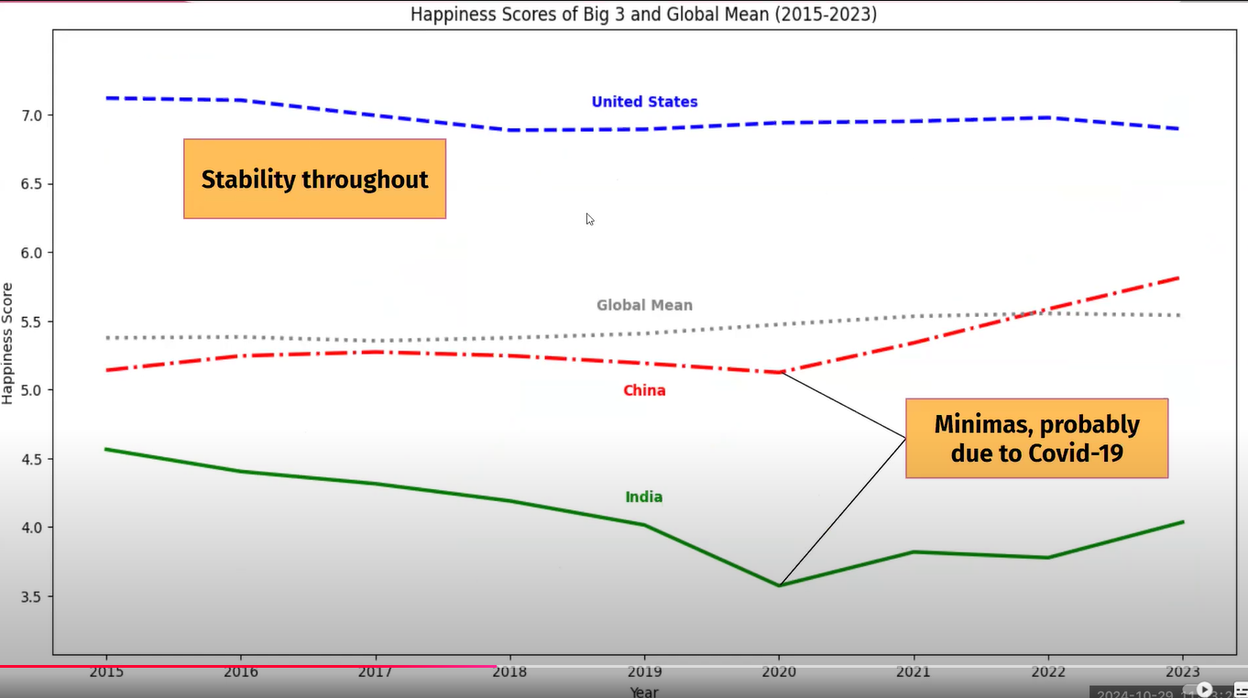
Figure 3. timestamp [2:07]

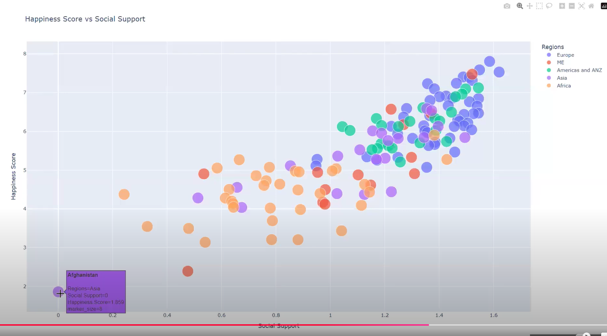
Figure 4. timestamp [3:14]
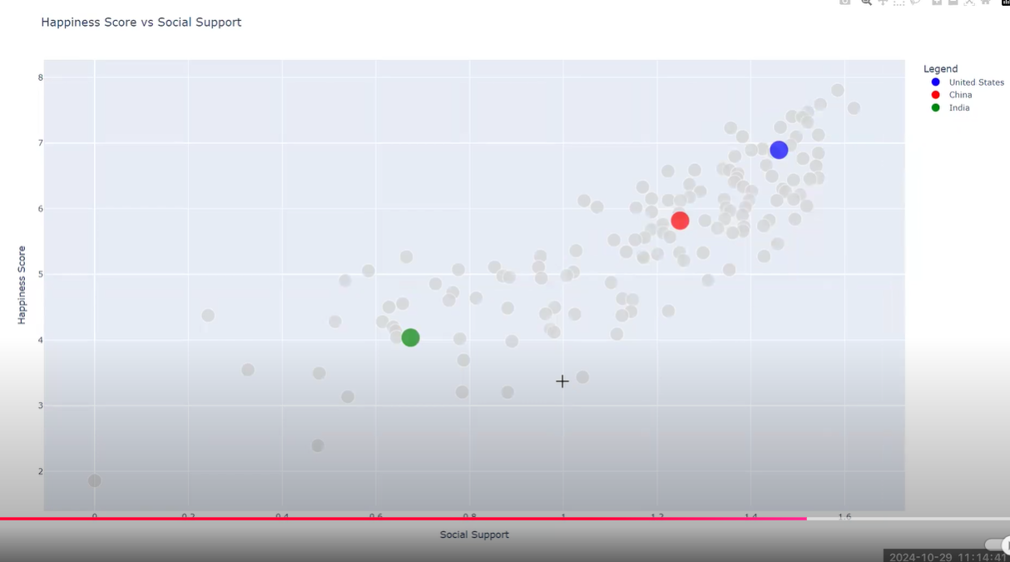
Figure 5. timestamp [3:26]

